Python installed on computer and added to PATH variable

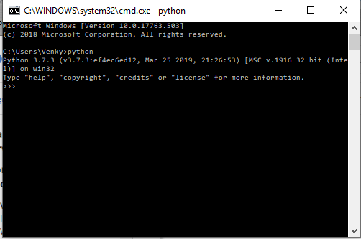

Python file “test.py” created in Atom

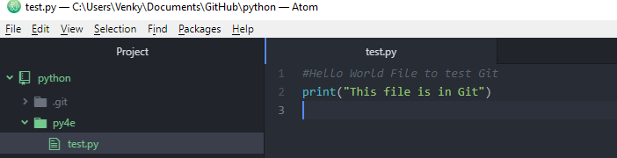

Executed “test.py” from command prompt

